Wireshark Lab 1

Introduction

Suraj Durgesht

(16EC06)

Instructor: Dr. Rajendra Hegadi

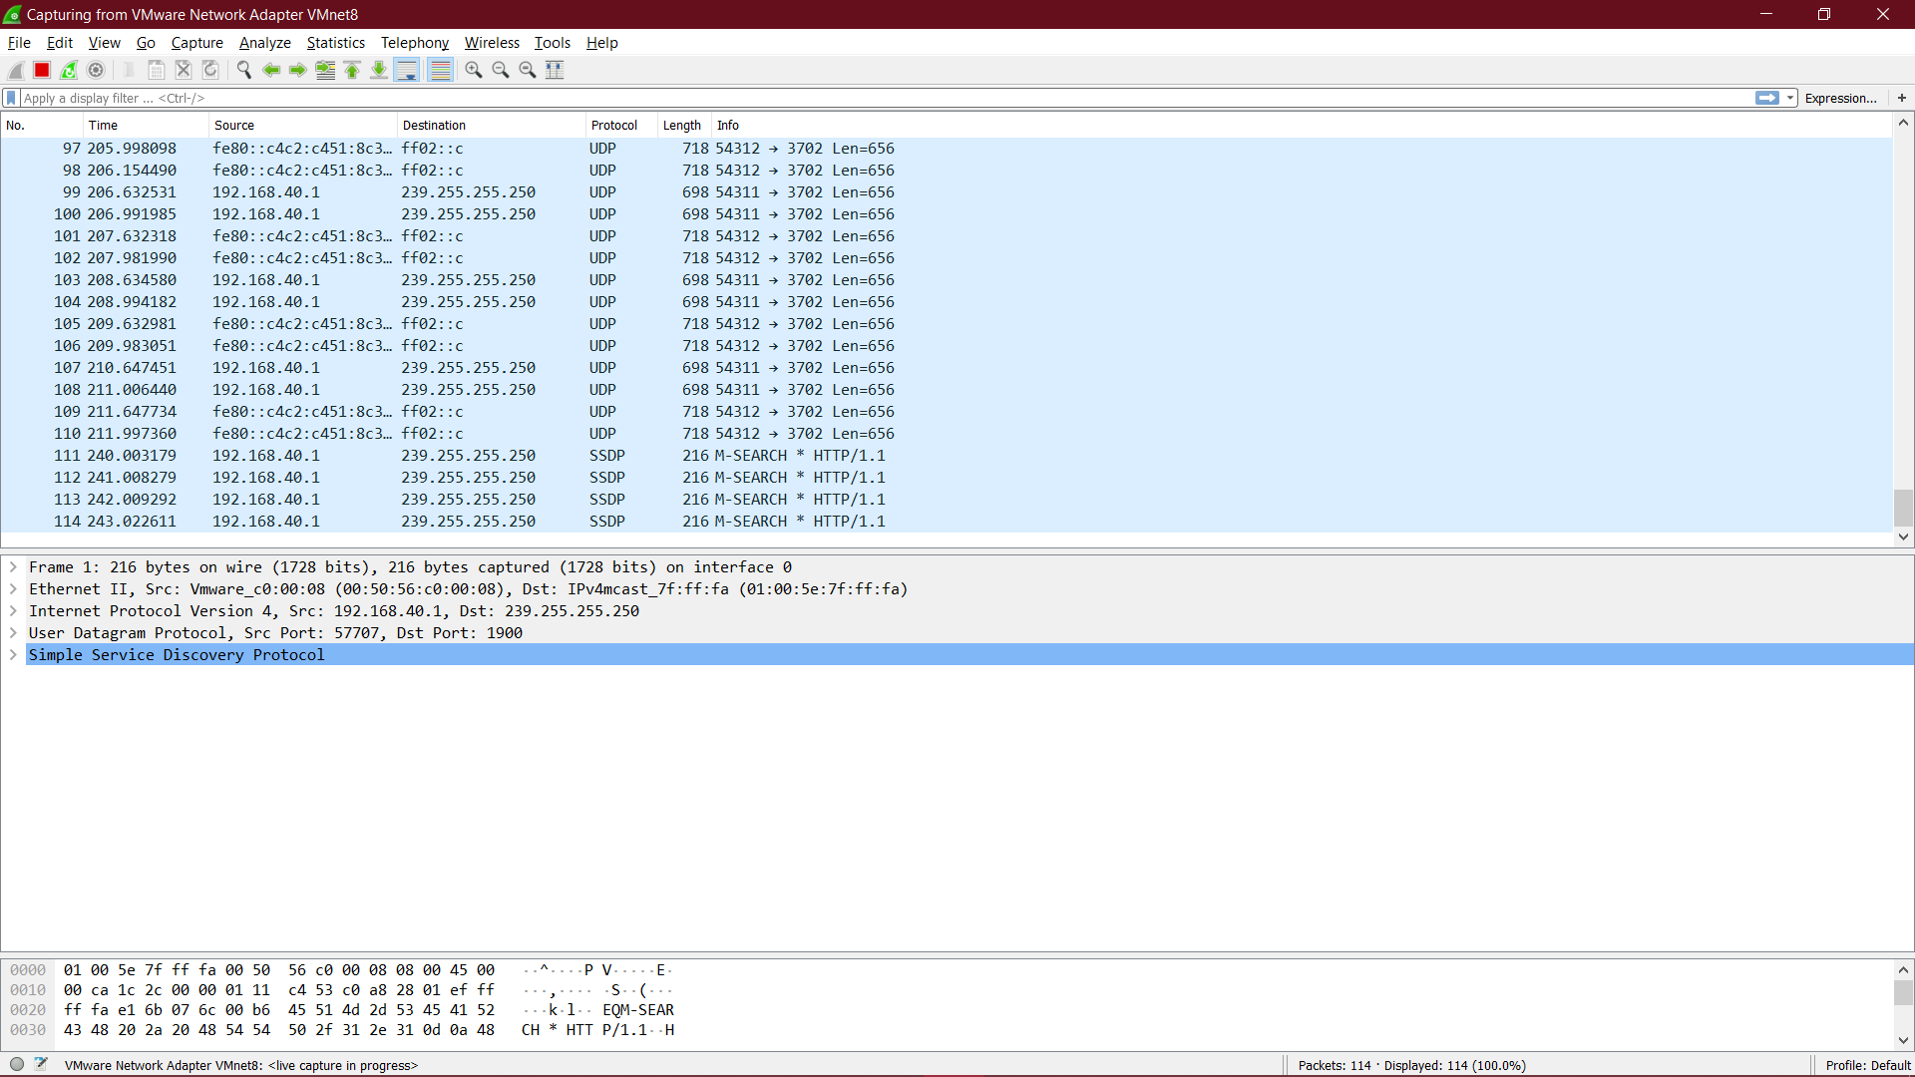

Que1. List the 3 different protocols that appear in the protocol column in the unfiltered packet-listing window in step 7 above.

Solution: UDP (user datagram protocol), TCP (transmission control protocol), ARP (Address Resolution Protocol), ICMP (Internet Control Message Protocol), MDNS (multicast DNS), SSDP (simple service delivery protocol), DHCP (dynamic host configuration protocol), ICMPv6, ICMPv3 and STUN (session traversal utilities).

Que2. How long did it take from when the HTTP GET message was sent until the HTTP OK reply was received?

Solution:

The GET was sent at 38.634816000.

and the reply was received at 39.204365000.

The delay was 0.569549secs.

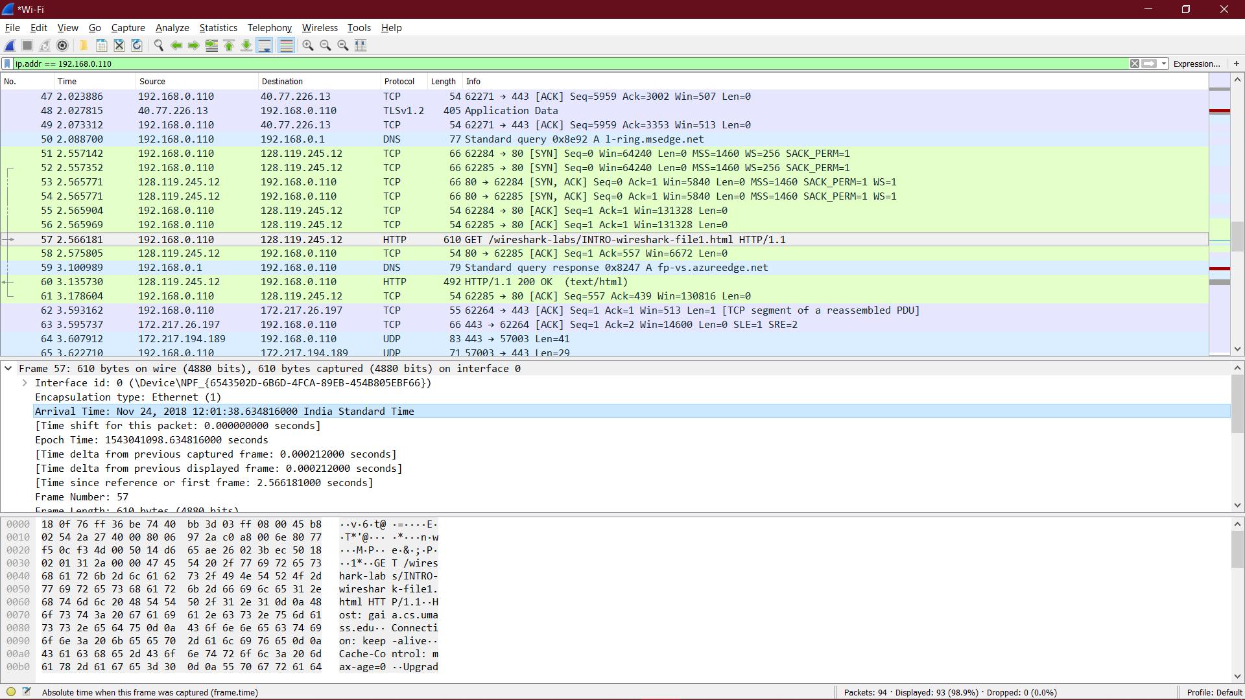

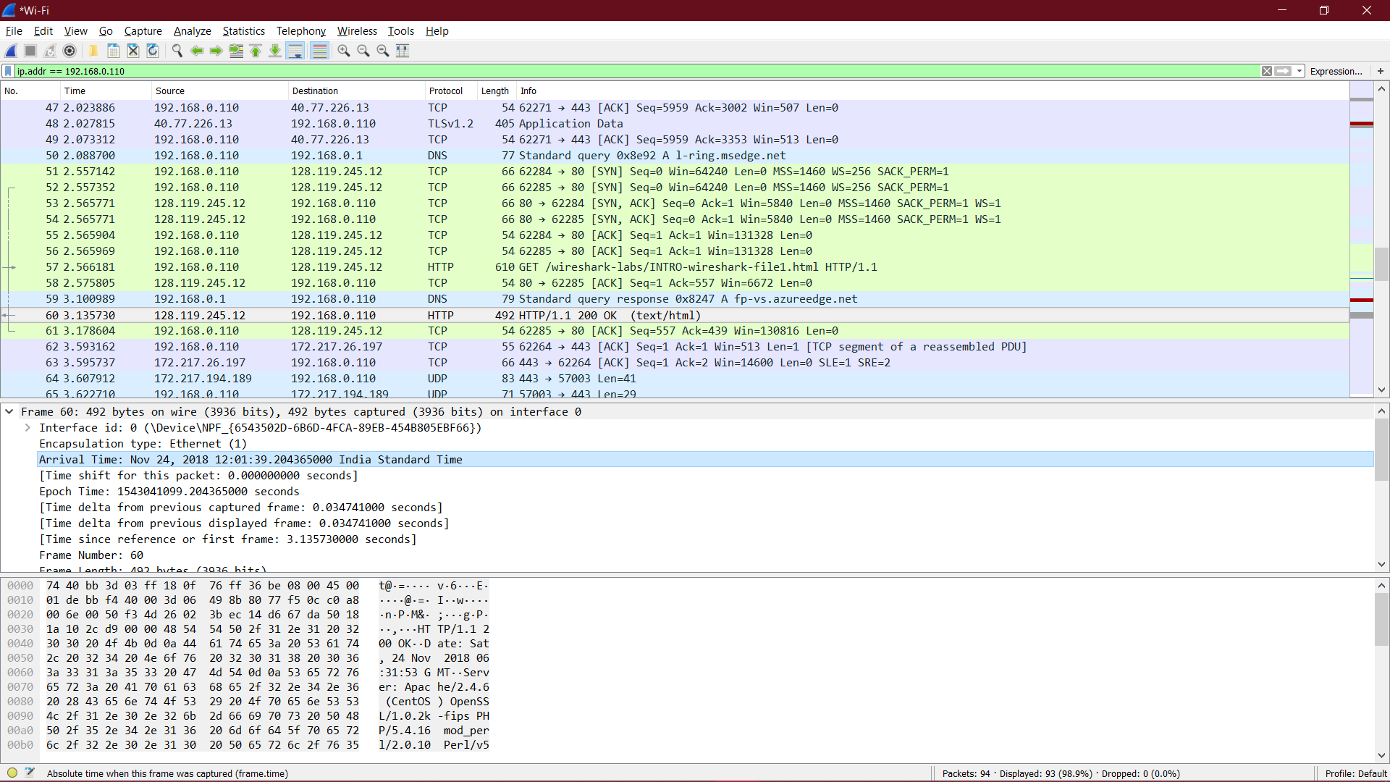

Que3. What is the Internet address of the gaia.cs.umass.edu? What is the Internet address of your computer?

Solution:

The IP address of gaia.cs.umass.edu is 128.119.245.145;

The IP address of my laptop is 192.168.0.110.

Que4. Print the HTTP GET and REPLY messages displayed in step 9. To do so, select Print from the Wireshark File command menu, and select the “Selected Packet Only” and “Print as displayed” radial buttons, and then click OK.

Solution:

